Dear Prospective Ohio Partners for Cancer Control Member:
We are writing to invite you to join the Ohio Partners for Cancer Control (OPCC) coalition. Formed in 2000, OPCC is a statewide coalition dedicated to reducing the cancer burden in Ohio. It is comprised of representatives from organizations who have cancer prevention and control as a focus of their mission. Representation includes hospitals, universities, cancer centers, health care professional associations, nonprofit organizations, government agencies, businesses, minority health coalitions, and community organizations. OPCC's mission is to create "A Cancer-Free Future for All Ohioans."
The Ohio Comprehensive Cancer Control Plan 2015-2020, (The Plan) developed by the OPCC coalition, includes many opportunities for cancer focused organizations, agencies, employers/businesses and individuals to be involved. The Plan contains three focus areas: Primary Prevention, Early Detection, and Patient-Centered Services. Within these focus areas, three priority objectives were chosen on which to focus for the 2016-2017 fiscal year. These include increasing the percentage of adolescents receiving the human papillomavirus (HPV) vaccine; increasing the percentage of adults receiving the recommended colorectal cancer screening; and increasing access to CoC standardized survivorship care.
We hope you agree that your membership would be a critical asset to our efforts. An application for membership in OPCC is attached. The time commitment to the coalition is minimal, but your input, expertise and experience are critical. The OPCC conducts two general in-person membership meetings per year, and committees meet via conference call as needed.
If you have any questions concerning involvement in OPCC, please contact either Leigh Anne Hehr or Bev Soult. We appreciate your consideration in joining the OPCC coalition!

Sincerely,
Leigh Anne Hehr Bev Soult
Leigh Anne Hehr, Executive Chair, OPCC Bev Soult, Executive Chair, OPCC
leighanne.hehr@cancer.org bsoult@cancersupportohio.org
Phone: 888.227.6446 Phone: 614.884.HOPE

The Ohio Comprehensive Cancer Control Plan 2015-2020
The Ohio Comprehensive Cancer Control Plan 2015-2020 (The Plan) is a strategic plan to reduce the cancer burden in Ohio. It is designed to provide guidance to individuals and organizations that play a role in controlling cancer.
The following materials were designed to help promote Ohio Partners for Cancer Control (OPCC) and The Plan to colleagues, constituents, other state and local stakeholders/partners and policy makers. The OPCC’s goal is to prevent and reduce the burden of cancer for all Ohioans.
- Q & A – General talking points that summarize the key points of The Plan for use during meetings, presentations, etc. It explains why and how the The Plan was developed and what it hopes to achieve and how to get involved.

- Fact Sheet – Table. Number of New Invasive Cancer Cases in Ohio 2013

- A Call to Action – Guidance for how various sectors, stakeholders and OPCC members can use The Plan to identify evidence-based objectives that fit specific community needs and align with a larger statewide effort.

For electronic copies of these materials and an OPCC logo that you can place on your organization’s website, go to http://www.healthy.ohio.gov/CancerPlan. For questions about the Ohio Partners for Cancer Control coalition, contact Linda Scovern at 614-728-2722 or Linda.Scovern@odh.ohio.gov.

Thank you for your commitment to preventing and reducing the burden of cancer in Ohio.

Q and A
Why does Ohio need to focus on preventing and reducing the burden of cancer?
- Ohio ranks 40th for overall health of its population in the country. A combined state ranking of health outcomes and healthcare costs shows that Ohio’s health value rank is 47, with Ohioans living less healthy lives and spending more on health care than people in most other states.¹

- Cancer claimed the lives of more than 25,000 Ohioans in 2012, at a rate (182.0 per 100,000) 9 percent higher than the U.S. rate (166.5 per 100,000). ²

- Rates for the most preventable risk factors: tobacco use, over exposure to sun, early detection and avoidance of preventative screenings are higher in Ohio than in many other states. ³

- In 2009 cancer cost the U.S. $86.6 billion in direct medical costs and $130 billion in indirect mortality costs (cost of lost productivity due to premature death), according to NIH reports. ⁴

- In the United States, about one half of all males and more than one third of all females have a lifetime risk of developing some type of cancer in their lifetime.⁵

- The risk for developing a cancer is shaped by social and economic conditions. Many cancers are more common and result in a higher mortality rate in minorities, those living in poverty or undereducated and people with mental illness or a disability.

What is Ohio’s Comprehensive Cancer Control Plan 2015-2020?
- The Plan is a five year guide to prevent and reduce the risk of cancer in Ohio. It was developed by Ohio Partners for Cancer Control (OPCC), a collaboration of organizations, distinct programs and individuals dedicated to reducing the cancer burden in Ohio and ultimately improve the overall population health.

- The purpose of The Plan is to develop, implement and evaluate a comprehensive plan to reduce cancer in Ohio through collaboration with a network of organizations, distinct programs and individuals. OPCC provides statewide leadership and coordination and serves as a catalyst for cancer prevention, control and patient-centered services throughout Ohio.
^{1.} Health Policy Institute of Ohio, 2015 ^{4.} National Institute Health, 2015
^{2.} 2012 United States Cancer Statistics ^{5.} Ohio Annual Cancer Report, 2015
^{3.} Ohio Annual Cancer Report, 2015
What does The Plan hope to achieve?
- The goal of The Plan is “A Cancer-Free Future for All Ohioans.”
- There are three focus areas to The Plan
- Primary Prevention: actions taken by individuals, communities, institutions and governments to protest against the occurrence of cancer
- Early Detection: reliable screenings conducted to find precancerous and cancerous abnormalities prior to the onset of symptoms
- Patient-Centered Services: specialized care for people with a cancer diagnosis that focuses on improving the quality of life for those persons and their support system
How was the Cancer Plan developed?
- The Plan was developed using the Centers for Disease Prevention and Control's (CDC) National Cancer Control Program Priorities.
- Emphasize Primary Prevention of Cancer
- Support early Detection and Treatment Activities
- Address Public Health Needs of Cancer Survivors
- Implement Policy, Systems and Environmental Changes (PSE) to Build Sustainable Cancer Control
- Promote Health Equity as it Relates to Cancer Control
- Demonstrate Outcomes through Evaluation
- The Plan has three guiding principles:
- Make data-driven decisions
- Use evidence-based interventions
- Identify and address cancer disparities and achieve health equity
How will The Plan going be implemented?
- The Plan will be implemented by the OPCC and other stakeholders.

- OPCC consists of partners from many sectors - communities, individuals, schools, healthcare, worksites, government and public health - working together to leverage resources and maximize reach.

- The OPCC coalition is open to all interested organizations/agencies/companies/individuals.

Fact Sheet
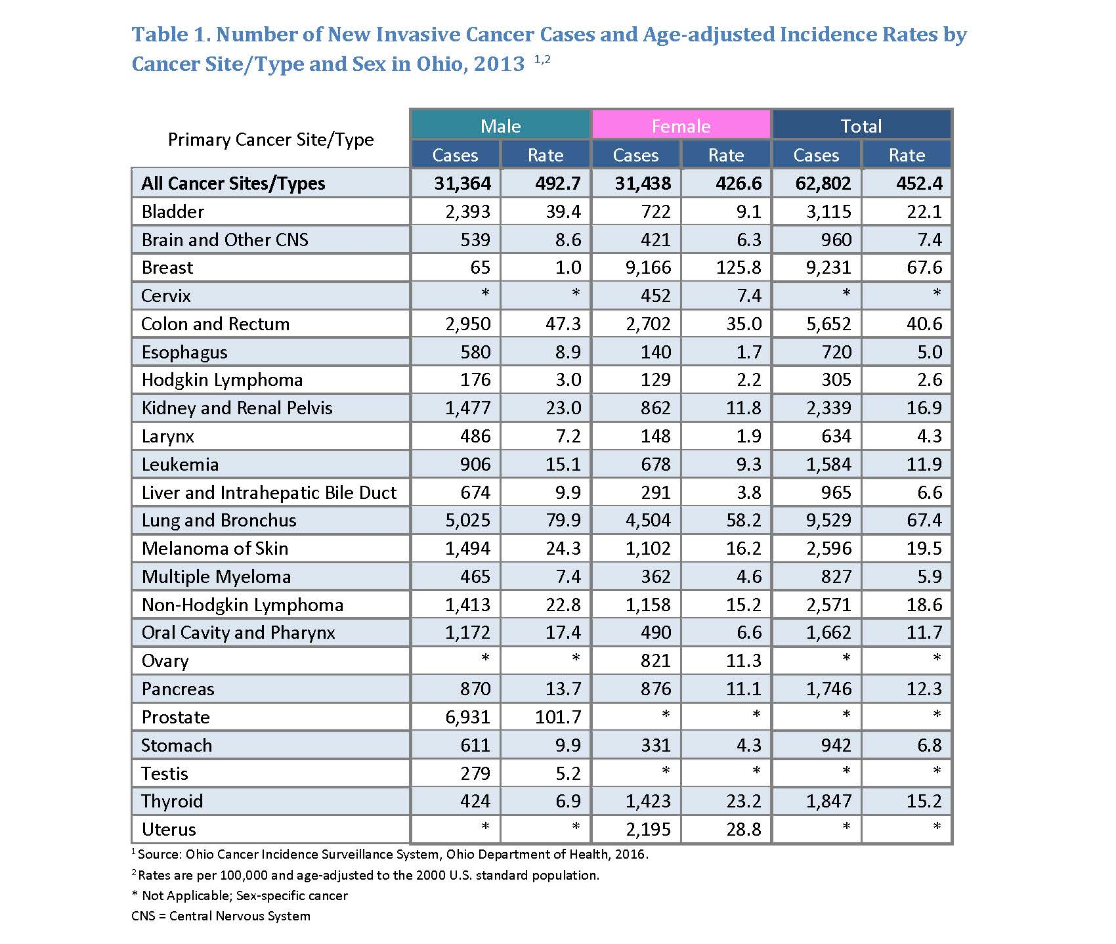

How can you get involved?
The Plan cannot be implemented by only a few organizations or agencies. Its success will be measured by the collective efforts of many partners in multiple sectors working together to help reach The Plan’s long-term goals.
Communities
- Your community-based cancer coalitions can use The Plan to identify the objectives and strategies that best fit the group's mission.
- Use The Plan to guide your community's health improvement plan and prioritize objectives that will best meet the needs identified in the group's data.
Schools and Universities
- Your school may have a cancer coalition or disease prevention committee which can use The Plan to prioritize objectives to align with other local and state activities.
- If your school or university does not have an active committee or coalition, how can you engage students, faculty, staff and parents to become members?
Healthcare Systems
- Partner with your local public health department to identify communities at risk and discuss how to use The Plan to fulfill the relevant objectives.
- As a healthcare provider, are you taking advantage of the evidence-based population health strategies in The Plan to improve your patients' overall health and wellness and prevent future cancer-related illness?
- Partner with local public health and community cancer coalitions and groups to conduct a community needs assessment and use The Plan to develop a local, regional or statewide health improvement plan.
Worksites
- Join the Healthy Ohio Business Council and make winning the Healthy Ohio Healthy Worksite Award one of your goals.
- Partner with your community cancer coalition to become engaged in other efforts to prevent and reduce the burden of cancer in Ohio.
- If your worksite has a successful worksite wellness program, are you mentoring other employers and business associates to join in similar efforts?

Governments – local, regional and national
- How can you ensure government agency employees work in healthy, safe environments and support the objectives in the plan?
- If your government agency a member of local and state cancer coalitions implementing strategies in The Plan?
- How can you leverage public health efforts and funding to ensure public policies and decisions positively impact the burden of cancer?
Individuals
- Spread the word in your households, schools, worksites, communities, places of worship, social media, etc. that everyone deserves opportunities to make patient centered decisions regarding their own healthcare.
- Become active in your local school wellness council, health coalitions or other groups working to improve the burden of cancer.
- Eat healthy foods, be physically active every day, and quit or never use tobacco products.
- Get recommended cancer screenings.
Funders
- How does The Plan fit into your organization or agency's strategic or business plan?
- Are there other local or regional funders that you can partner with to maximize funding, impact and reach?
- Align your funding with programs, strategies and activities within The Plan.
- Use The Plan to help strengthen other efforts to address the social determinants of health.

Individual Healthcare Providers
- How do The Plan’s services fit into your provider's offerings?
- Are there gaps that need to be addressed either because they are inconsistent with or unfair to the patient?

A call to action!

- Align with the larger statewide effort by using The Plan to identify the evidence-based objectives that best fit your community's specific needs.

- Join the OPCC coalition to share your progress and help meet The Plan’s measures.

The success of The Plan relies on the collective efforts of many partners in multiple sectors working together to help reach its long term goals. For information on how to join the OPCC coalition, contact Linda Scovern, linda.scovern@odh.ohio.gov or 614-728-2722.

